Xavier Frederick

CYB 210

6/13/2021

6-2 Project One Submission: Network Modification Brief

For this project I was tasked with

A. Properly configure the VLAN for guest and video connections to meet the project requirements.   
  
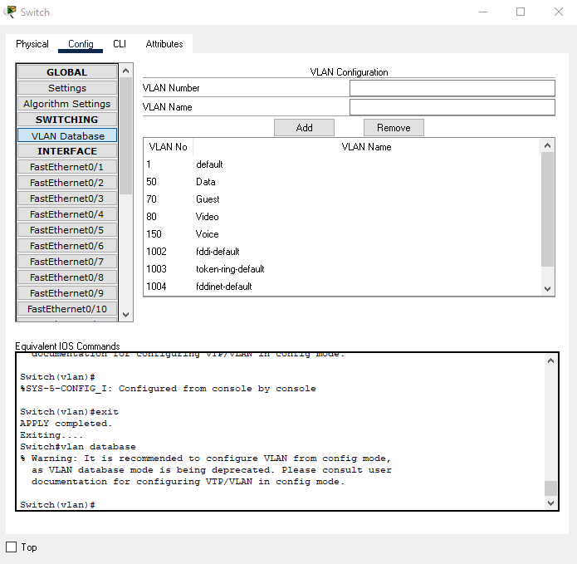

B. Properly configure the guest wireless network to meet the project requirements. 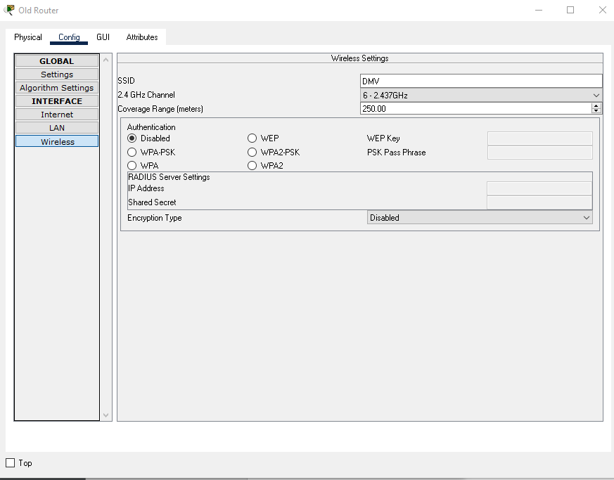

C. Make sure that devices are connected to the guest wireless network to meet the project requirements and make sure that cameras are connected to the video network to meet the project requirements.

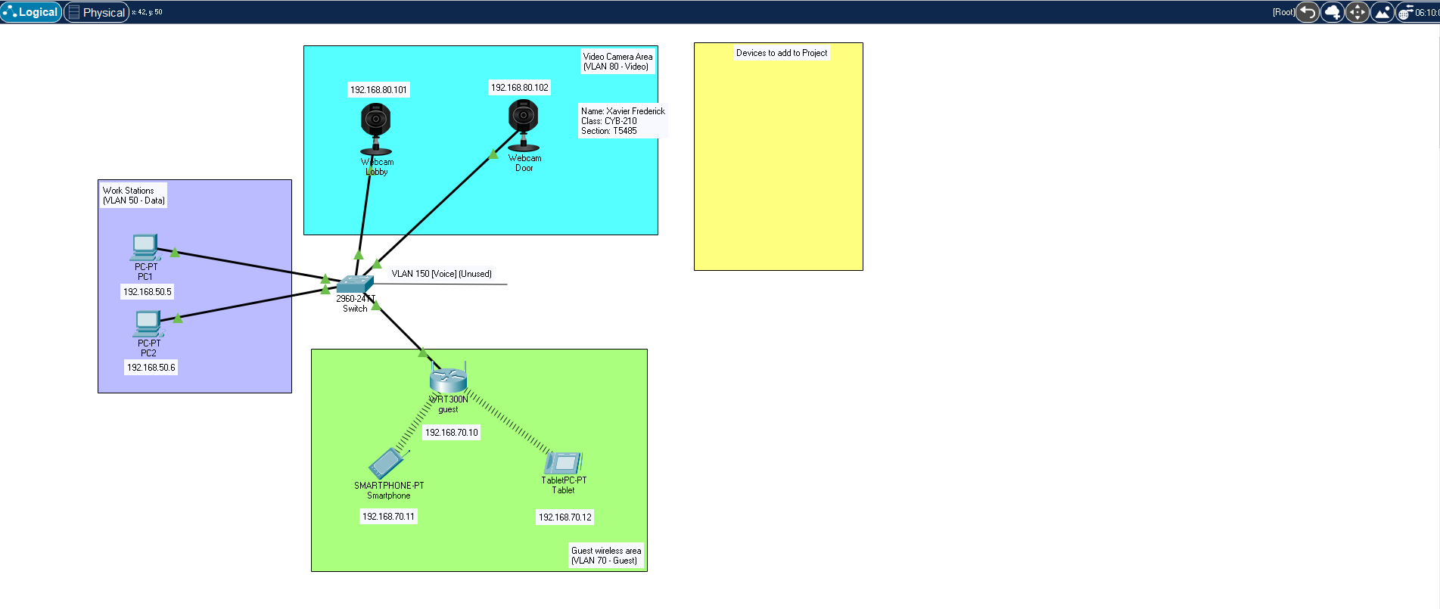 D. Make sure that guest and video networks are properly segmented. ( test ping from tablet to lobby camera.)

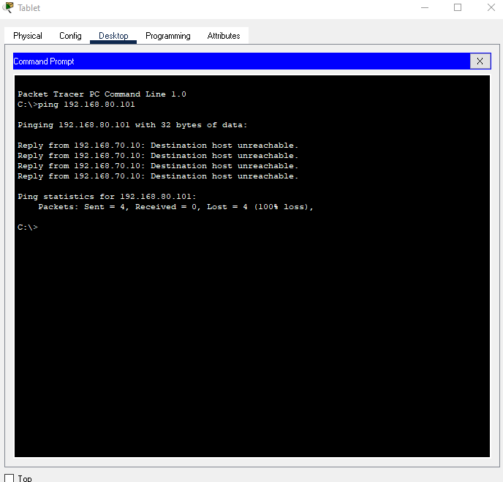

For this project I segmented the guest from the video Network by Configuring another VLAN Name and Number in the VLAN database for the switch. For the Fastethernet0/2 and 0/3 the VLAN name and number is set to “Video-80”. This allows the data traffic from the other VLAN areas of the network to not interfere with the camera connection and data. For example, the Guest area which is connected on Fastethernet0/1 to a router in the guest area is set up on VLAN name and number “Guest-70” and as a result is unable to communicate with the camera VLAN area.  
  
Since the guest network is an open network, the settings I used are to limit the amount of connections that can be had on the router while simultaneously limiting the amount of time the connection has on the router. In the DHCP settings in the GUI I made sure to manually map the starting IP address as 192.168.70.10, set the maximum users to 70 and set the client lease time to zero. This allows toe router to connect to the switch, while allowing only 70 individuals to gain access to the router at the same time for only up to 24 hours.  
